30 Webinars in the EoE (Season 2)
Approved for 50 RCPath CPDs
Organisers: Drs Salma Al Ramadhani, Preethi Gopinath, Maria O’Donovan, Vasi Sundaresan
www.histopathologyCPD.com Email: histopathologyCPD@gmail.com

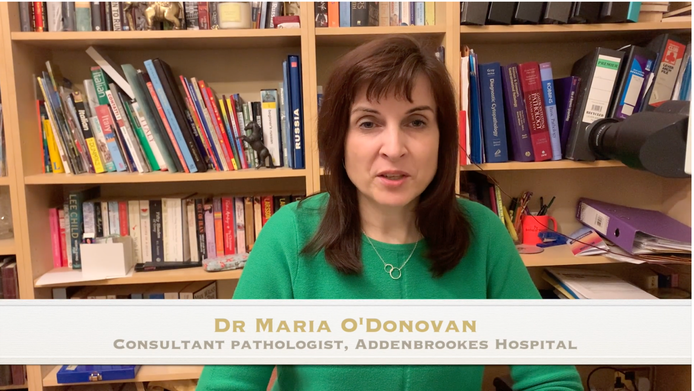

Course Registration Link Press here

Target Audience: Consultant Histopathologists and trainees in the UK and overseas who want to refresh or update their current knowledge.
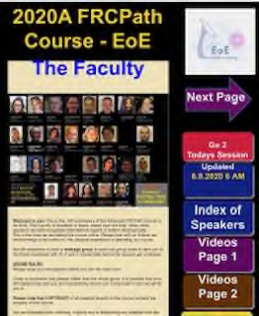
Course Content: Each webinar will cover a specialty topic with the updates centred on scanned slides. Two of the sessions cover updates on post-mortem which will be delivered in lecture format: examination of the brain and of the cardiorespiratory system.
The emphasis will be on interpreting the histology in the context of clinicopathological correlation. The level of difficulty of the cases will be varied and will aim to imitate real-life cases, ranging from straight-forward diagnoses to complex cases that require further work and central review. The case selection will be similar to what may be seen in an EQA setting and in many sessions topics covered will include diagnostic and interpretive challenges.
Delivery of Webinars: Due to the Covid-19 pandemic, the course organisers have had to adjust to delivering a totally virtual webinar series of teaching sessions.
- These will be delivered on the Zoom platform enabling anyone with internet access and an Android or Apple device to access the webinars.
- The webinar sessions will run from 10am to 12pm on Saturdays to accommodate overseas delegates and the faculty to deliver the webinars.

- The faculty will present approximately 20 cases highlighting important diagnoses in routine practice and will discuss relevant management issues and provide clinicopathological correlation.
- These sessions will be recorded.
- Access to the course materials to those wishing to review course materials (scanned slides and Videos-with links) will be through the app on both IoS and Android Tablet. Those with fixed commitments on Saturday will be able to review course materials after the event and a reflective note would facilitate recognition for CPD purposes.
- Those with iPads or Android tablets can have the course material uploaded automatically a week in advance on the tester app (appstudio). Usernames and passwords will be provided once registered and course fees are paid.
- The answers to the cases/slides and the videos hosted on Vimeo will be available for viewing on the appstudio platform which is username and password protected.
CPD Points
The webinar will be a useful resource containing a range of diagnostic material across all main subspecialties in Histopathology and Cytopathology.
Each webinar will last for 2 hours amounting to 2 CPD points/webinar. Delegates will be able to view approximately 20 slides before sessions and writing a reflective note will enable a further CPD point per session.
For those Consultants that view slides before the Webinar and attend the entire programme, the total number of CPD points will be 50+30 (50 RCPath approved CPD points and 30 CPD points for reflective notes).
Those who attend the session live will be sent a certificate of attendance with a CPD certificate at the end of each session.
Trainees (not CPD registered) will be sent a certificate of attendance. Those Consultants (registered for RCPath CPD) viewing slides and following the videos need to write a reflective note to document they have followed the webinars and self-accredit for CPD.

 | Early Bird |  | After Sept 30th
 | Consultants | Trainees (No CPD) | Consultants | Trainees (No CPD)
All Webinars | £500 | £300 | £600 | £400
7 GI Webinars | £200 | - | £250 | -
7-Breast & Gynae | £200 | - | £250 | -
4 Urology | £100 |  | £150 | -

Registration Link Press here
Speakers and Webinar Topics Nov 2021-2022
1 | 13 Nov | Prof Neil Shepherd | Polyps and tumours of the Gastrointestinal Tract
2 | 20 Nov | Prof Naveena Singh | Pitfalls in reporting of endometrial pathology
3 | 27 Nov | Prof Marco Novelli | Dysplasia in the upper GI Tract
4 | 4 Dec | Dr Maria O’Donovan | Sponge technology: implementation in early screening of oesophageal dysplasia and cancer diagnosis
5 | 11 Dec | Prof TuVinh Luong | CUP: Practical tips for the practising pathologists
6 | 18 Dec | Dr Alison Marker | Head and Neck Pathology - a practical approach
7 | 8 Jan | Dr Alison Marker | Problems and pitfalls in endocrine pathology
8 | 15 Jan | Dr Elena Provenzano | Reporting of post chemo- breast and axillary specimens
9 | 22 Jan | Dr Andrew Lee | Diagnostic pitfalls of breast core biopsy diagnosis
10 | 29 Jan | Prof TuVinh Luong | The Good, the bad and the ugly in GEP-NET Pathology
11 | 5 Feb | Prof Norman Carr | Mucinous Appendiceal Tumours and their differential diagnosis
12 | 12 Feb | Dr Shaun Walsh | IBD: Common types and Mimics in Biopsy Diagnosis
13 | 12 Mar | Prof Hazem Ibrahim | Approaches to Difficult Melanocytic Lesions
14 | 19 Mar | Prof Naveena Singh | Reporting of Vulval lesions-Devil and other entities
15 | 26 Mar | Dr Baljeet Kaur | Products of Conception: when to worry about them?
16 | 2 April | Dr Anne Warren | Variants of Bladder Cancer and discrimination from mimics and metastatic tumours
17 | 9 April | Prof Naveena Singh | Role of Immunostaining in the female genital tract
18 | 23 April | Dr Anne Warren | Renal Cell Carcinomas – syndromic variation and immunostains in the DGH setting
19 | 7 May | Dr Ashish Chandra | Head & Neck Cytology (excluding LN)
20 | 14 May | Prof Maria Calaminici | Cytopathology of the Lymphoid System: advances and limitations of making a rapid diagnosis
21 | 21 May | Dr Ashish Chandra | Exfoliative cytology including serous effusions
22 | 28 May | Dr Ashish Chandra | Urine Cytology and nuances of Paris Classification
23 | 11 June | Dr Anne Warren | Update on reporting of Testicular Germ Cell Tumours
24 | 18 June | Dr Hibah Ali | Everyday Haematopathology: Lymphoma mimics and pitfalls
25 | 25 June | Dr Rupali Aurora | Borderline tumours and tumours of the Ovary
26 | 2 July | Dr Alex Freeman | Update on Reporting Prostatic Cancer
27 | 9 July | Dr Kieren Allinson | Unexpected findings on neuropathological examination of the brain
28 | 16 July | Dr Hibah Ali | Watch out for Lymphoma: Extra-nodal Entities
29 | 23 July | Professor A Flanagan | Common malignant soft tissue lesions seen in the DGH setting
30 | 30 July | Drs Kieren Allinson Martin Goddard | Post-mortem examination of the Brain and the Cardio-respiratory system: Update

